

**ÇANKAYA UNIVERSITY FACULTY OF ENGINEERING COMPUTER ENGINEERING DEPARTMENT**

**Project Report**

**Version 2**

**CENG 408**

**Innovative System Design and Development II**

Formun Üstü

**<*201906*>**

**AI CUSTOMER SUPPORT SYSTEM**



M. Atakan Demircioğlu

201511018

Alperen Sarınay

201511048

M. Cavid Aydın

201511004

Arınç Alp Eren

201611020

Advisor: Assist. Prof. Dr. Roya CHOUPANI

##### Co-Advisor: Lecturer Ph.D. Faris Serdar TAŞEL

**A Review of the Computer Science Literature Relating to AI Customer Support**

Arınç Alp Eren, Alperen Sarınay, M. Atakan Demircioğlu

and M. Cavid Aydın

Department of Computer Engineering, Çankaya University

15 May 2020, version 2.0

**Abstract**

We design a web-based customer support system that using machine learning. This system can be installed on any website. With our project, we aim to reduce the time wasted and cost of customer service. Artifical Intelligence based support systems are at the center of attention of customers and companies. These systems are rapidly replacing with old systems. In our research, we searched about how artificial intelligence can be integrated into support systems in general and why it should be used.

**1 Introduction**

Nowadays, most successful companies provide customer service. A customer support system helps an organization manage customer service requests and interact with customers to resolve them. Customers receive answers to their questions or seek solutions to their problems. Company officials also try to solve problems. It is a very challenging stage for companies to answer questions in a continuous, uninterrupted, accurate and fast manner. Continuous live support to customers is a very high cost. We will work on a much more practical system to reduce the cost of this service. We want to solve the problems of people in this area easier, faster and more accurately. Customers will not expect their questions to be answered by the authorities. They will receive quick answers directly generated by the system. Customers will not expect their questions to be answered by the authorities. They will receive quick answers directly generated by the system. We think this is very important for customer satisfaction.

Our system, which can be installed automatically, will not require any code information from the users and thus the users will be able to use our system easily. We want to create a machine-integrated forum with robust infrastructure with advanced, easy-to-use panels.

In this literature research, we will investigate the following subjects; live support systems, artificial intelligence, machine learning, deep learning, web development, related computer issues, etc.

**2 About Our Project**

We are aiming to create a web system that can be installed on any website. In our system, we will be creating a customer support system which is machine learning based program that can train itself according to the questions asked and also answers given by the non-machine (human) supporters. For every website, our program will have its’ own dataset on the computer it is installed. For every solved issue which means question and its’ true answers at the end (does not matter how many questions asked and true or false answers given between these two), machine learning program will create a model and after a while it will start answering questions instead of non-machine supporters.

AI Customer Support will be focused on E-Commerce websites. We will develop our project on this scope. Our project is designed to create its own specific dataset for companies but during development we will use ready datasets to test, train and develop our machine learning algorithm. Also our program can only understand English language.

**3 Why We Choose This Project?**

This service is a service where customers can ask the authorities live the problems they have with the company or the product. Customers receive answers to their questions or seek solutions to their problems. Company officials also try to solve problems. It is a very challenging stage for companies to answer questions in a continuous, uninterrupted, accurate and fast manner. Continuous live support to customers is a very high cost. We will work on a much more practical system to reduce the cost of this service. We want to solve the problems of people in this area easier, faster and more accurately.

**4 What Is CRM?**

CRM ,which is called Customer Relationship Management, is a technology for managing all your company’s relationships and interactions with customers**[1]**. A CRM is important for companies because every customer can have problems with their products or softwares. To make it easy for customers to stay connected with customer service, companies use CRM. But even though we are in nearly 2020, CRMs are not still automated by machines. Our goal is to create a machine learning based AI system that can handle problems by itself without any help from us, humans.[2]

**4.1 CRM Usage**

There are many companies[3] that provides CRM programs for other companies. Many of them are using “Ticketing System” that is mailing to the customer service via CRM program. We are not aiming to create a ticketing program, instead we want a support system that can be used publicly. Like a form, people can interract with other problems and say they have the same problem or offer another solution.

The companies we found throughout our search are not using a system that has any artificial intelligence in it and also many companies use CRMs that use Ticketing System which is we don’t want to use.

**5 Systems And Frameworks**

**5.1 What Is Jenkins?[4]**

Jenkins is a automation tool. Jenkins is often used by organizations to speed up the software development process. Jenkins provides these with build, deploy and test capabilities that can be provided automatically. This tool writen by Java and it is very important for Continuous Integration. Jenkins is already a server-based application and it can run with Apache web server.

Since we wanted to do Continuous Development while developing the project, we installed this tool on our own compute engine. In this way, we gave everyone the opportunity to work from anywhere. This tool, which is actively working on our server, automatically builds the site files every time the commit comes and everyone can see the change on live.

**5.2 What is jQuery?[5]**

JQuery is basicly a JavaScript library that more easy than other JavaScript libraries. Most of biggest companies are using jQuery in development proccess. We choose jQuery to use PHP more dynamically.

**5.3 What is Bootstrap?[6]**

Bootstrap is a popular CSS Framework that allowing responsive design. We are considering a responsive design in the project and we decided to use this CSS framework. In this way, we plan a system that works well on all platforms.

**6 Why Machine Learning?**

Machine learning is an application of artificial intelligence (AI) that provides systems the ability to automatically learn and improve from experience without being explicitly programmed. Machine learning focuses on the development of computer programs that can access data and use it learn for themselves.[7]

Data is the lifeblood of all business. Data-driven decisions increasingly make the difference between keeping up with competition or falling further behind. Machine learning can be the key to unlocking the value of corporate and customer data and enacting decisions that keep a company ahead of the competition. We asked to ourselves, why don't we use the questions and answers asked to companies as data?

When companies integrate our system, they will use machine learning in the background so that they can provide automatic answers to customers in the live support system.

In our project’s machine learning part, we want to use Python as a programming language. In the light of the information we have found from different source throughout our research, 9 out of 10 sources put Python first. The reasons behind our Python decision are the existence of a massive number of frameworks and libraries for machine learning and great source of information on the internet.[8]

**7 Algorithms**

**7.1 Machine Learning Algorithms**

Machine learning algorithms can show various success rates depending on the type of data set. It is very difficult to decide exactly which algorithm to use without trying these success rates on the dataset.[10]

In our research we found that we need to use the following algorithms :

5 supervised learning techniques- Linear Regression[11], Logistic Regression, Naïve Bayes, KNN.[12]

3 unsupervised learning techniques- Apriori, K-means, PCA.[13]

**8 Why We Want To Use Web?**

Web development has been improving since its founding.[14] Every company, small businesses, artisans need websites. Also, with the development of the technology sector, serving the customer easily and succesfully has become even more important. As you can see Web Development and Customer Services are non-ending industries. With the help of internet, we aim to reach as many people as we can.

In our project’s web part, we will be using PHP, Python, JavaScript, HTML and CSS as programming languages.[15] HTML, CSS and JavaScript are must programming languages for web development. We will use Python for machine learning program as we mentioned earlier. Also, PHP offers a great database management, dynamic and fast usage. In addition, PHP has a big source of information.

**9 Similar Companies To Our Project**

**9.1 Company Name : DigitialGenius[16]**

DigitalGenius is an AI platform that uses speech in autopilot to understand conversations, automate repetitive processes. How to use DigitalGenius in customer support operation DigitalGenius is installed as an application to your existing customer service software. Connects your CRM to our AI platform; then train your first buy model and start answering the given questions. Once DigitalGenius is configured and the model is self-taught, you can add it to your agents and start automating incoming queries from start to finish.

**9.2 Company Name : Maruti Techlabs[17]**

Wotnot is a chat creation platform that creates intelligent, identifiable bots for your company. WotNot enables your company to automate interactions with your users, obtain information, and manage multiple communication channels. Increases your sales and marketing support with virtual assistant.

**9.3 Company Name : LivePerson[18]**

LivePerson is a company that is focused on AI-based Technologies such as chatbot and messaging platforms. LivePerson company has 2 main products which are AI-powered Bots and Messaging Channels.

Messaging channels are an interface between customers and brands via an AI chatbot and makes it easy to find products and purchasing.

AI-powered bots are simply a chatbot creation program that you can automate up to %70 of messaging conversations on your website, SMS, Facebook Messenger, WhatsApp etc.

ÇANKAYA UNIVERSITY

Software Requirements Specification

AI CUSTOMER SUPPORT SYSTEM

Alperen Sarınay, Arınç Alp Eren, M. Atakan Demircioğlu, M. Cavid Aydın

**15.05.2019**

**1 Introduction**

**1.1 Purpose and Scope**

This document is a software requirement feature for the web application ai customer support project. Main purpose of this document is to give detailed information about the functionalities, constraints and software requirements of the project. The purpose of this document to describe our project, AI Customer Support. The main objective of the project is a system developed to provide faster and more reliable answers to the questions asked in the support parts of e-commerce sites on web platforms. AI Customer Support is a web system that can be installed on any website. In our system, we will be creating a customer support system which is machine learning based program that can train itself according to the questions asked and also answers given by the non-machine (human) supporters. For each website, our program will use its own data set on the computer where it is installed. If there is no data set on the computer, our system will create its own data set for each question asked and the correct answer after installation. For every solved issue which means question and its’ true answers at the end (does not matter how many questions asked and true or false answers given between these two), machine learning program will create a model and after a while it will start answering questions instead of non-machine supporters.

**1.2 Glossary**

**Term** **Definitions**

|  |  |
| --- | --- |
| CRM | *Customer Relationship Management  * CRM is a technology that allow you to manage your company’s relationship and interactions between customers. |
| AI | * Artificial Intelligence |
| Machine Learning | * Machine learning is an application of that provides systems the ability to automatically learn and improve from experience without being explicitly programmed. |
| Dataset | * Set of data that is grouped under titles. |

**2 Overall Description**

**2.1 Product Perspective**

AI Customer Support project is CRM-like system that any E-Commerce based company and business can use it. Our system will have 2 seperate parts. First part is frequently asked questions (FAQ) which is group of questions and answers that are created by admins and also AI itself. Second part is forum that customers can ask questions. These questions can be answered by admins and also with AI system. But because our AI system is machine learning based system, companies must train it. After enough training, AI system will work and answer questions by itself.

**2.2 Memory Constraints**

AI Customer Support will require at least 1 CPU, 3GB Ram and minimum 15GB space.

**2.3 Operations**

Customers can do several operations on our system. Customers can search for asked questions, which is FAQ, from search bar so they can easily find a solution if the problem already solved. Also customers can share their problems with comunity and create an issue at Forum part. These problems can solved by admins or AI system. After the answers given by admin or AI system, customers should decide whether the solution is true or false. This operation is needed for machine learning training.

On the other hand, if customers decide that the solution is wrong, admins will be notified about this issue so they will solve the problem instead of AI system.

**2.4 Site Adaptation Requirements**

Companies must have a website and a domain to use our system. The only thing companies must do is to drag our files to their original website files.

**2.5 Product Functions**

AI Customer Support system will have 4 different parts. This parts are Profile, Homepage (All Questions), Question and Sign Up.

**Profile**

* Notification button located on the page navigation bar will open a Pop-Up box that show all the notifications, also user can click on them and will be redirected to the related page.
* With Activity button, user can see all questions they asked before and also by clicking on questions, they can go to the question page.
* Edit Profile button will lead user to the profile options page so they can change their informations like password, email, nickname, profile picture etc.

**Use Case Diagram for Profile Page**

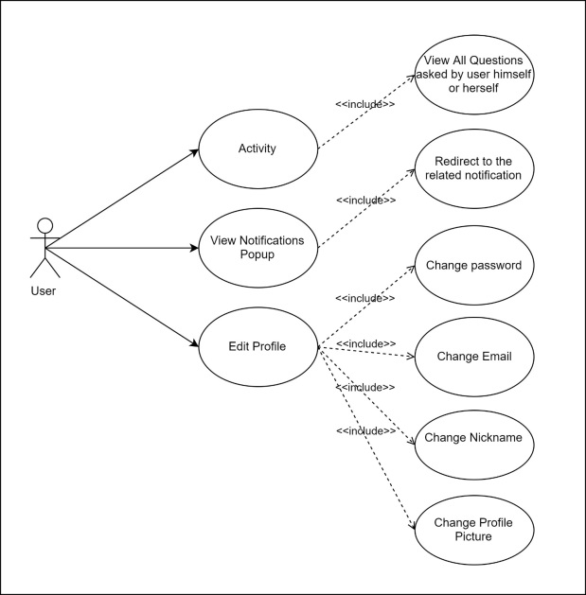

**Homepage (All Questions)**

* Users can input keywords on search box and find their problem if it asked before instead of asking a new questions.
* Filters can be applied on search to make it easy to find the exact problem.
* Time Filters are used to show all question asked since last day, week, month or year.
* Score Filters will sort all questions according to their score in ascending or descending order.
* View Filters will sort all questions according to their view counts in ascending or descending order.
* Show only FAQ Filter will show only Frequently Asked Questions which are created by company owners.
* With Ask Question Button users will be redirected to the page that users can create a question just like on the forum pages. Asked questions won’t be available until it’s marked as “resolved” by user itself. (see Question part)
* By clicking on the question, users will be redirected to the question page.

**Homepage (All Questions) Use Case Diagram**

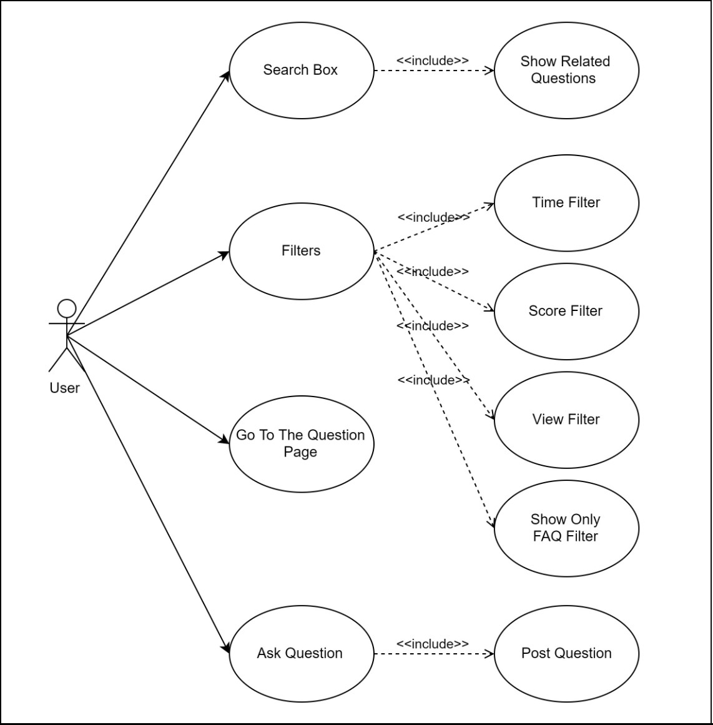

**Question**

* With question voting system, we aim to create a system to create high scored questions so common problems can be found easily by users. Although questions can be voted by users, answers can’t be voted because no answer can be published until it’s fully solved. Because all the answers must be %100 accurate, voting the answers would be meaningless.
* Questions can be answered by only real supporters or AI system.
* Users must verify the answer as “resolved” or “unsolved” so that machine learning can train itself according to accuracy of the answer. Question and related answer won’t be published until users confirm the answer as “resolved” so wrong solutions will not be available in our system.

**Question Use Case Diagram**

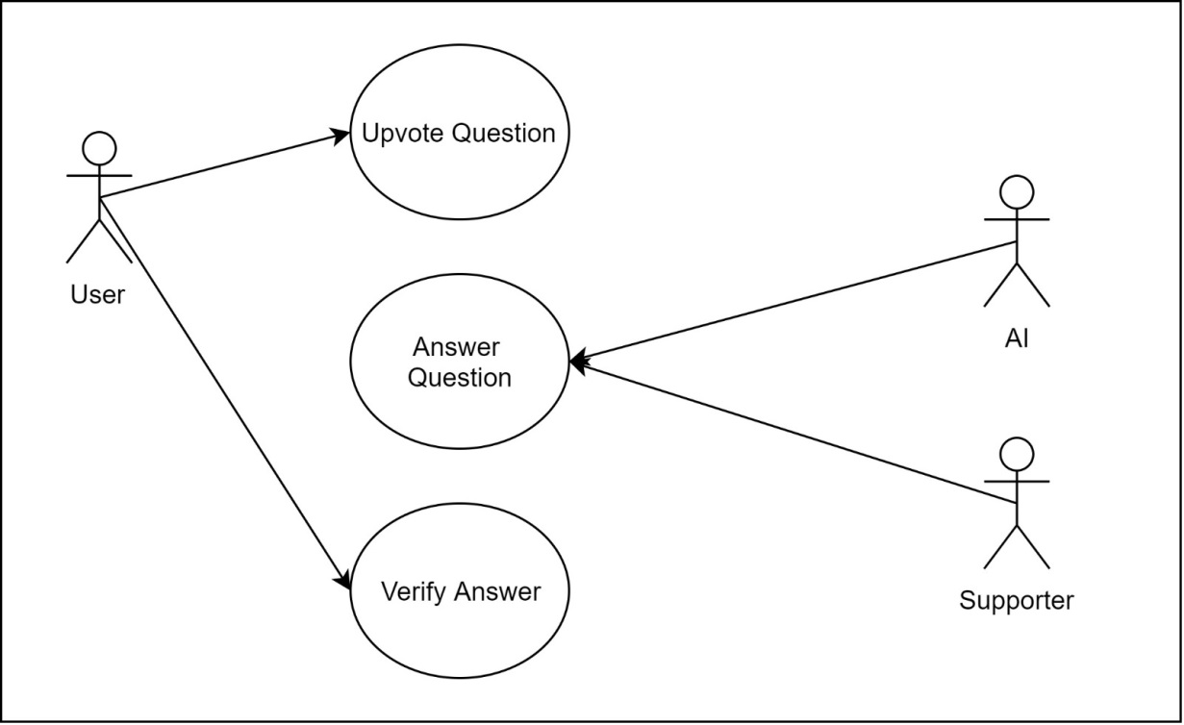

**Sign Up**

* To vote and ask question, users must sign up on our system. On sign up page, users must specify their informations such as name, surname, email, password etc.

**Sign Up Use Case Diagram**

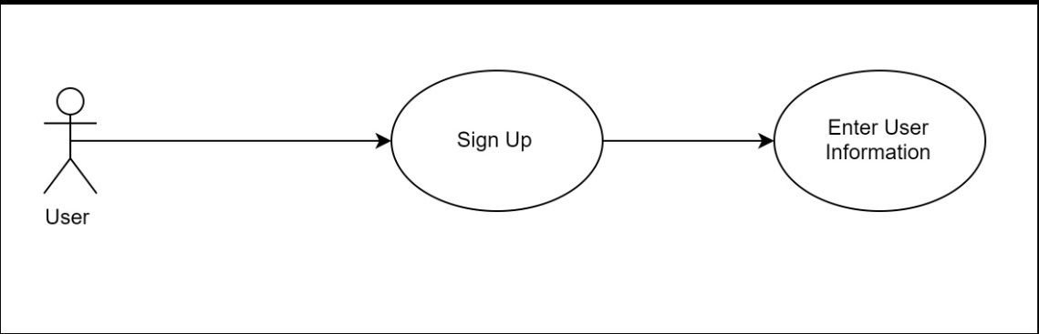

**2.6 User Characteristics**

Because of our system designed for English questions and answers, customers and companies should understand English language.

**2.7 Constraints**

Our system designed for E-Commerce related customer problems with language of English. So any other topics and languages are not supported. Any website that meets these requirements can use our system.

**2.8 Assumptions and Dependencies**

Company website must have PHP on their machine to run our system.

**3 Specification of Requirements**

**3.1 External Interface Requirements**

**3.1.1 User Interfaces**

Our system is a web project and it will have a responsive UI suitable for all platforms. For this we will use bootsrap in the project.

#### **3.1.2 Hardware Interfaces**

#### For install the system; user must have a host and probably a domain name. Host must have this system requiretments;

* Minimum 1 CPU
* Minimum 1 GB of RAM
* Minimum 15 GB Space
* Ethernet

#### **3.1.3 Software Interfaces**

Any device that (have browser to access internet) can access the website is sufficient to use the system. For install the support System we recommend host supports;

* PHP version 7.3 or greater then this version.
* Linux Or Ubuntu OS
* MySql 5.6 or greater
* HTTPS support (for SSL).

#### **3.1.4 Communications Interfaces**

User need a web browser to connect website. For this reason firstly must have internet connection.

#### 3.1.5 Performance Requirements

The most important thing in web-based systems is of course the internet connection. It is also very important that the server can respond to different requests at the same time. For his reason, we will test our software with Apache AB Test before launching. Also we recommend users must test their servers after install our software.

**3.2 Software System Attributes**

**3.2.1 Portability**

* AI Customer Support will use PHP, Javascript and Phyton. So, our project will be available at all platforms like Mobile Phones, Tablets and PCs.
* The system is a web based project and it not require different hardwares for users. But who installs the software must have a basic host.
* All computers and phones will be avaible to use our system.

**3.2.2 Performance**

* Good internet connection is important. Especially the power of the internet where the server is located is very important. Must be fiber. It may be wise to use more than one machine in a wide range of applications, or to separate machines for a database.
* User must have a server that can handle multiple users and multiple requests. For this we have suggested some system requirements above.

#### **3.2.3 Adaptability**

#### In the system we have designed, companies will start to keep all the questions asked in their data base as soon as they download AI Customer Support system and adapt it to their website.

#### 3.2.4 Safety Requirements

Since we design a system where customers can easily access everything and receive feedback, it will not cause any inconvenience for our users.

**4 Planning**

**4.1 Team Structure**

Team Members: Alperen Sarınay, Arınç Alp Eren, M. Atakan Demircioğlu, M. Cavid Aydın.

**Task** **Member**

|  |  |
| --- | --- |
| Web Front-End | Alperen Sarınay – M. Atakan Demircioğlu |
| Web Back-End | M. Atakan Demircioğlu – M. Cavid Aydın |
| UI design | Alperen Sarınay – Arınç Alp Eren |
| Machine Learning | Arınç Alp Eren – M. Cavid Aydın |
| Artificial Intelligence (AI) | Alperen Sarınay – M.Atakan Demircioğlu |
| Dataset Manupilation | M. Cavid Aydın – Arınç Alp Eren |
| Advertisement – Seo | M. Atakan Demircioğlu |

**4.2 Estimation**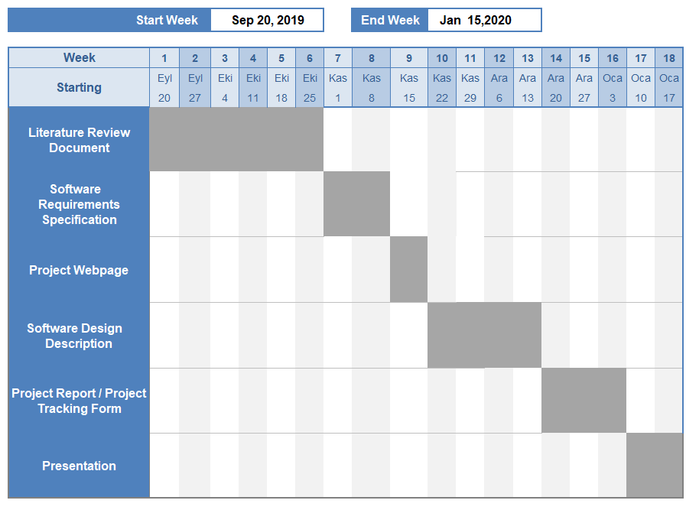

**5 Conclusion**

This software document is intended to explain the details, system and hardware requirements of the AI Customer Support system. At the same time, the project we developed will not only be an idea, but also better planning with the models. With the help of our SRS documentation, it will be more easier to implement and use our system on your website.

ÇANKAYA UNIVERSITY

Software Design Description

AI CUSTOMER SUPPORT SYSTEM

Alperen Sarınay, Arınç Alp Eren, M. Atakan Demircioğlu, M. Cavid Aydın

**15.05.2019**

1 Introduction

* 1. Purpose

Purpose of this Software Design Document (SDD) is to specify the technical and software requirements of our AI Customer Support Project. For our project, the target auidence is E-Commerce based companies.

* 1. Scope

This document explains the details of AI Customer Support. AI Customer Support is a system where artificial intelligence answers the questions asked in the support system of internet-based companies. Companies will be able to implement and use this system to their website without writing code.

Artificial intelligence in our system is a system that trains itself by learning the questions asked and the answers given to the questions and in time it starts to give more accurate results. This process continues to train itself until it finds the most accurate answer.

* 1. Glossary

**Term** **Definitions**

|  |  |
| --- | --- |
| CRM | *Customer Relationship Management  * CRM is a technology that allow you to manage your company’s relationship and interactions between customers. |
| AI | * Artificial Intelligence |
| Machine Learning | * Machine learning is an application of that provides systems the ability to automatically learn and improve from experience without being explicitly programmed. |
| Dataset | * Set of data that is grouped under titles. |

1.4 Overview of Document

The remainder of the document includes design-related information, Requirements Traceability, User Interface, Input Devices Subsystem, Data Model and Storage, and Data Storage.

1.5 Motivation

We're a senior in computer engineering. Because of our interest in artificial intelligence and the web sector, we decided to do such a project. In addition, we see that the current position of the web sector in the developing world economy is rising rapidly. Lastly, we can show that Ali Express Company sold 21 billion dollars in the first 6 hours on 11.11.2019[1]. So, we have decided that it is necessary to have support systems that respond automatically in a sector where such high sales figures are achieved.

2 Design Overview

2.1 Description of Problem

Nowadays, the use of the Internet has become widespread and most large companies provide their support systems online over the internet. In this sense, we are developing smart support software that they can use without writing code. In addition, users will be answered directly by bots, not people. We will provide this with ai.

2.2 Technologies Used

Our AI Customer Support system is designed to suit all platforms. In this sense, it is possible to use from mobile, tablets and computers. However, browser and internet connection is required for the devices to be used.

It is recommended that the people who will install our system have domain name and hosting. Because our system is a web-based and online system.

2.3 Architecture Design of AI Customer Support System

2.3.1 Profile Page

**Summary :** Users can change or update their information from their profile (password, username, etc ..). They can also track how many questions they have entered into our system.

**Actor :** Users

**Precondition:** User must login.

**Basic Sequence:**

1. User must register if she or he does not have an account.

2. User must login to the system by entering his or her username and password.

3. User can update his or her personal information by selecting “Edit” button from profile page.

4. User must enter new information about himself or herself after clicking “Edit” button and click “Save” button.

**Exception :** If database is not installed , database connection can be failed.

2.3.2 Question Page

**Summary :** Users can see question , answer and also comments. In addition users can comment on any question.

**Actor :** Users

**Precondition:** None.

**Basic Sequence:**

1. User does not need to login or register for displaying the question page.

2. User must login to the system to comment on questions.

3.User can click any tag for displaying related questions with that tag.

**Exception :** If database is not installed , database connection can be failed.

2.3.3 Home Page

**Summary :** Users can login, register, search for all questions and apply filter on questions. Also user can go to install page with “install Now” button and go to ask question page with “Ask a Question” button if user is logged in.

**Actor :** Users

**Precondition:** None.

**Basic Sequence:**

1. User does not need to login or register for displaying the home page.

2. User can see question list.

3. User can login or register.

**Exception :** If database is not installed , database connection can be failed.

2.3.4 Ask Question Page

**Summary :** Users can ask a question and edit the question text.

**Actor :** Users

**Precondition:** User must login.

**Basic Sequence:**

1. User must login to the system by entering his or her username and password.

2. User must enter question title, description, tags and edit description with style button.

3. User can “Submit” the question.

**Exception :** If database is not installed , database connection can be failed.

2.3.5 Install Page

**Summary :** Admin must enter server name, username, password and database name. Also with the help of checkbox, admin can reset the database.

**Actor :** Admin

**Precondition:** Admin must config the config file.

**Basic Sequence:**

1. Admin must config the config file.

2. Admin must enter server name, username, password and database name.

3.Admin must click “Register” button.

**Exception :** None.

2.4 Class Diagram

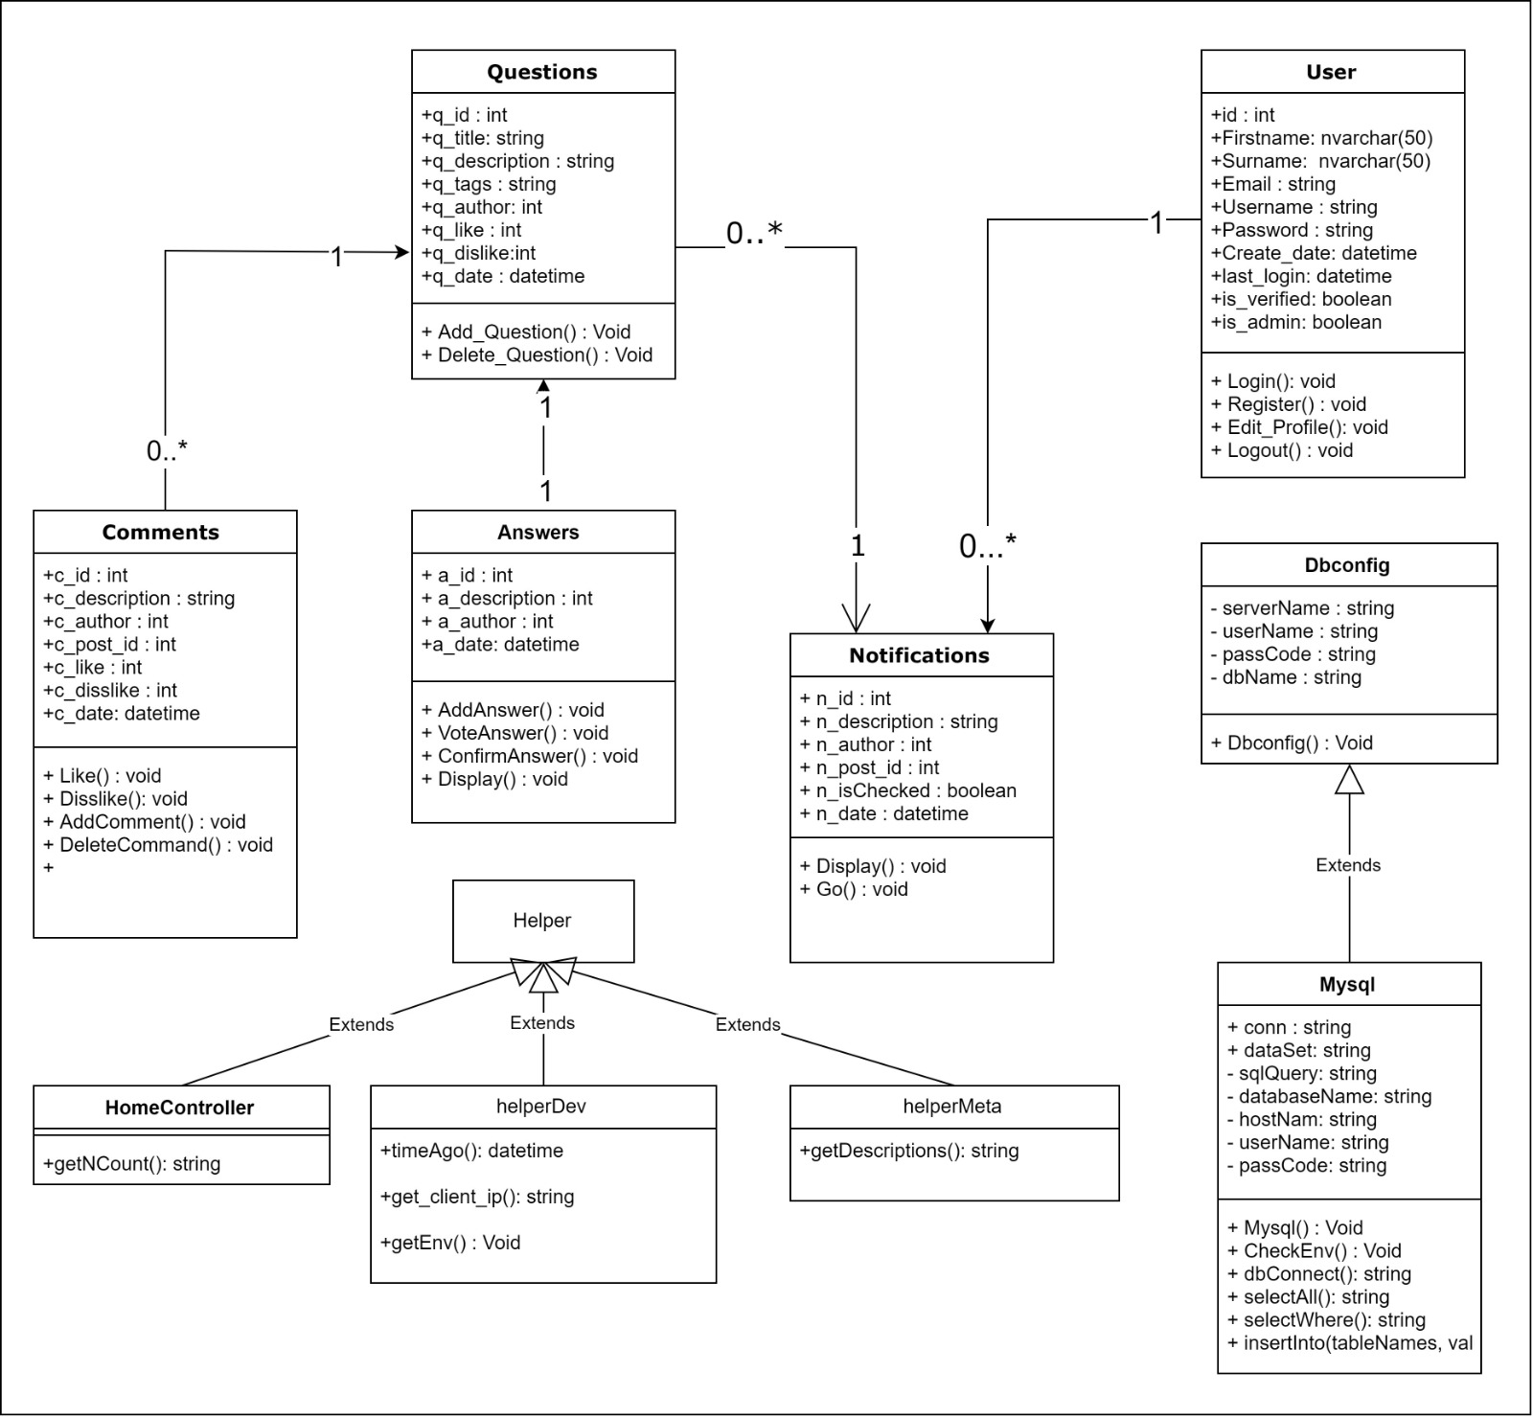

2.5 Activity Diagram

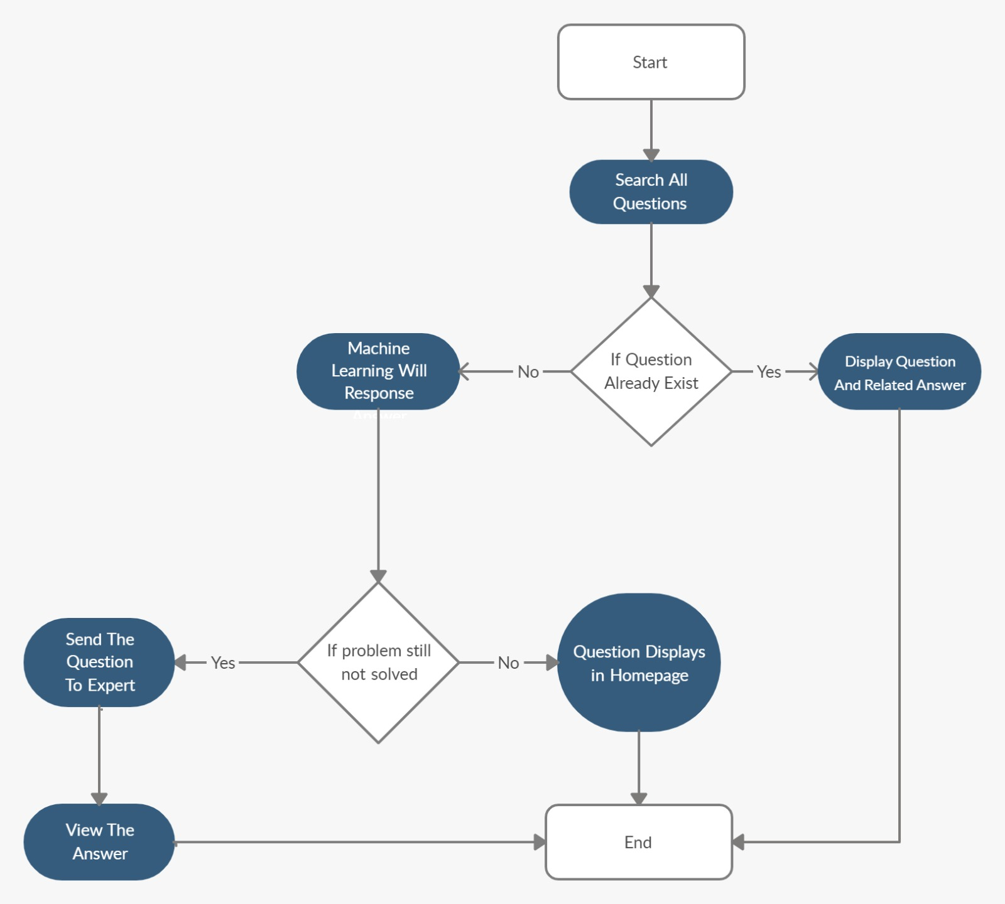

3. USE CASE REALIZATIONS

3.1. AI Customer Support System

### C:\Users\Alperen Sarınay\Downloads\UseCaseRealization (1).jpg

### 3.1.1 UI Design

### The User Interface (UI) design is made to explain the interactions between the user / authorized user and the system. The UI design has six sub-systems:

**Register Page :**  Designed for users to register to the system using their personal information.

(First name, Last name, Username, Email Address, Password)

**Login Page :** Registered users, e-mail addresses and passwords are designed to log in to the system.

**Profile Page :** Designed for allow registered users to view and update their contact information.

**Home Page :** Designed for users to log in, register, search all questions, and filter the questions.

**Install Page :** Designed for users to use the system easily.

**Question Page :** Designed for users to see questions, answers and comments.

**Ask Question Page** : Designed for users to add question.

### 3.1.2 Database Design

Database Design has been made to ensure that the data required for the operation of the system is stored. Essential for database design: entities, tables and relationships.  We will have four entities: Users, Questions, Comments and Notifications.

### 3.1.3 User Function Design

Users register to our system after, they will be able to install the customer support system we have prepared for their e-commerce sites. In addition, they will be able to ask any questions or questions they may have about our system on the question page. They will be able to see the questions asked by other users and the automatic answers given by the system we have installed.

3.1.4 Administrator Panel Design

This panel can be only available and accessible for administrators and experts. Administrator panel lets admins to edit a user or question or comment or anything else. Admins can delete questions, ban or suspend personal accounts. Also admins can analyze many statistics such as how many user using the system or type of questions asked by users.

## 3.2 User Interface

### 3.2.1. Register Page

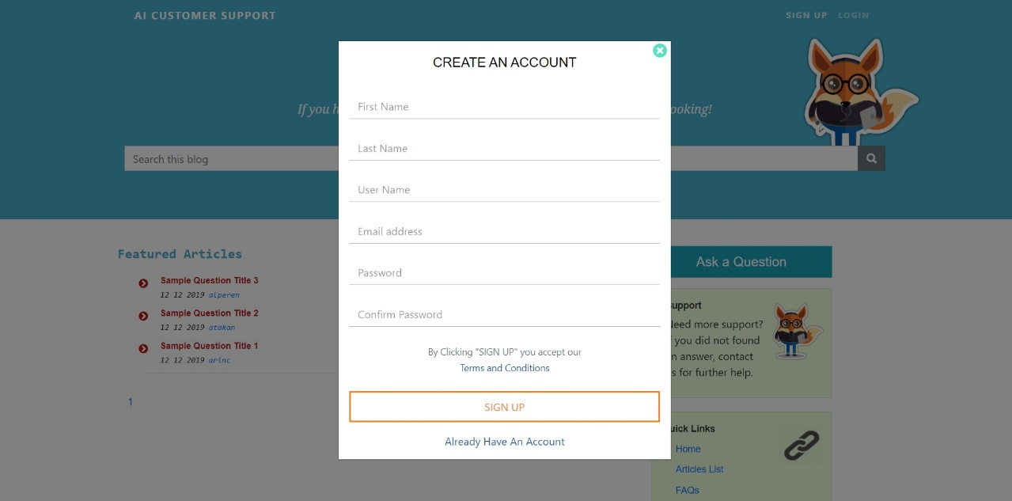

Register page is designed for non-registered users. Users must fill “First Name”, “Last Name”, “User Name”, “Email address”, “Password” and “Confirm Password” parts. Password and Confirm Password must match. Also registered users can click on “Already Have an Account” button and redirect to login page.

### 3.2.2 Login Page

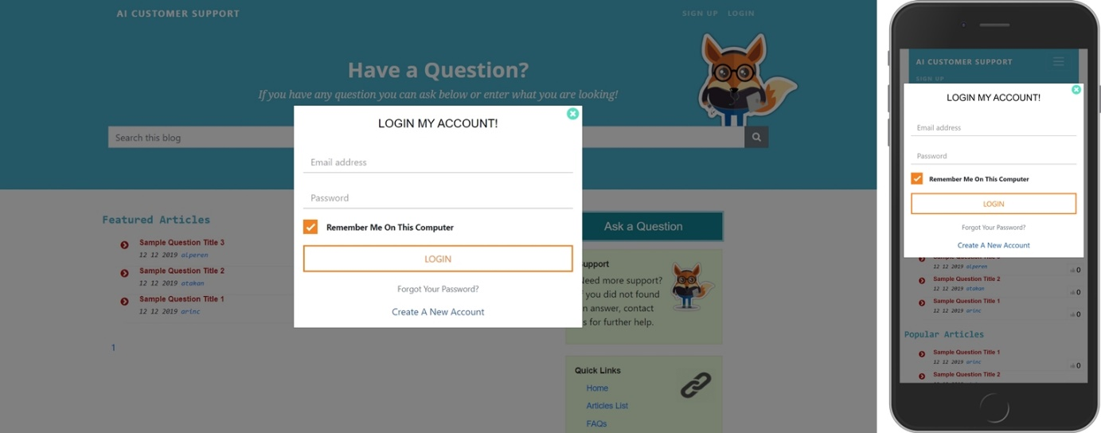

Users must fill the “Email address” and “Password” parts. If any of these informations are incorrect, an alert will show up. Also, if user check the “Remember Me On This Computer” checkbox, users will not need to login again anymore until they logout manually.

## 3.2.3 Homepage

## **1920x1080Homepage-horz**

## On homepage, any user (does not matter if they have account or not) can see featured and popular articles. With search bar, users can search questions by specific keywords across our systems. Also, registered users can ask question with “Ask a Question” button.

## 3.3.4 Profile Page

## **1920x1080Profile-horz**

## Users can see their personal informations such as First Name, Last Name, Email, Username and Password. Also with “Edit” button, users can edit the corresponding information. In addition, asked question count and profile page can be seen on left.

## 3.3.5 Question Page

## **1920x1080SampleQuestion-horz**

## On Question Page, any user (does not matter if they have account or not) can see the related question and tags. Also they can comment on question if comments are allowed.

## 3.3.6 Ask Question Page

## **1920x1080addquestion-horz**

# Registered users can ask question on this page. With the buttons, they can edit their question description. Users must fill the Question Title, Description, Tags and Submit.

## 3.3.7 Install Page

# C:\Users\Alperen Sarınay\Desktop\install-horz.jpg

# Install page is only available for administrator. With install page, owners must fill the “Servername”, “Username”, “Password”, “DB Name” and Register. With “Reset Database” checkbox, admins can reset database.



**ÇANKAYA UNIVERSITY**

**FACULTY OF ENGINEERING**

**COMPUTER ENGINEERING DEPARTMENT**

**Test Plan, Test Design Specifications and Test Cases**

**Version 1**

**CENG 408**

Innovative System Design and Development II

**AI CUSTOMER SUPPORT SYSTEM**

Arınç Alp Eren - 201611020

Atakan Demircioğlu - 201511018

M. Cavid Aydın - 201511004

Alperen Sarınay - 20151148

Advisor: Roya CHOUPANI

Contents

**1. INTRODUCTION** 4

**1.1 VersionControl** 4

**1.2 Overview** 4

**1.3 Scope** 4

**1.4 Terminology** 4

**2. FEATURES TO BE TESTED** 4

**2.1 Graphical User Interface (GUI)** 4

**2.2 Database (DBS)** 5

**2.3 Machine Learning Program (MLP)** 5

**3. ITEM PASS/FAIL CRITERIA** 5

**3.1 Exit Criteria** 5

**4. REFERENCES** 5

**5. TEST DESIGN SPECIFICATIONS** 5

**5.1 Graphical User Interface (GUI)** 5

**5.1.1 Subfeatures to be tested** 5

**5.1.1.1 Login (GUI.LOGIN_BTN)** 5

**5.1.1.2 Register (GUI.RGSTR_BTN)** 5

**5.1.1.3 Ask a Question (GUI.ASAQ_BTN)** 5

**5.1.1.4 Logout (GUI.LOGT_BTN)** 5

**5.1.1.5 Profile (GUI.PROF_BTN)** 5

**5.1.1.6 Admin Panel (GUI.ADP_BTN)** 6

**5.1.1.7 Categories (GUI.CTGRS_BTN)** 6

**5.1.1.8 Notification (GUI.NOTIF_BTN)** 6

**5.1.1.9 Like (GUI.LIKE_BTN)** 6

**5.1.1.10 Dislike (GUI.DLIKE_BTN)** 6

**5.1.1.11 Profile Edit (GUI.PROFE_BTN)** 6

**5.1.1.12 Admin Panel Install (GUI.ADPIN_BTN)** 6

**5.1.1.13 Admin Panel General Settings (GUI.ADPGS_BTN)** 6

**5.1.1.14 Admin Panel Users (GUI.ADPUR_BTN)** 6

**5.1.1.15 Admin Panel Questions (GUI.ADPQS_BTN)** 6

**5.1.1.16 Admin Panel Categories (GUI.ADPCT_BTN)** 6

**5.1.1.17 Admin Panel Comments (GUI.ADPCM_BTN)** 6

**5.1.1.18 Admin Panel Dashboard (GUI.ADPDB_BTN)** 6

**5.1.1.19 Question Links (GUI.QLINK_BTN)** 6

**5.1.1.20 Question Show Comments (GUI.QUSCO_BTN)** 6

**5.1.1.21 Question Tags (GUI.QTAGS_BTN)** 7

**5.1.1.22 Question Post Answer (GUI.QUPAN_BTN)** 7

**5.1.2 Test Cases** 7

**5.2 Database (DBS)** 10

**5.2.1 Subfeatures to be tested**10

**5.2.1.1 Database Queries (DBS.DBQRY)** 10

**5.2.2 Test Cases** 11

**5.3 Machine Learning Program (MLP)** 11

**5.3.1 Subfeatures to be tested** 11

**5.3.1.1 Cosine Similarity (MLP.COSIM)** 11

**5.3.2 Test Cases** 11

**6****.** **DETAILED TEST CASES** 12

**6.1** **GUI.LOGIN_BTN.01** 12

**6.2** **GUI.RGSTR_BTN****.01** 12

**6.3** **GUI.ASAQ_BTN****.01** 13

**6.4** **GUI.LOGT_BTN****.01**13

**6.5** **GUI.PROF_BTN****.01**14

**6.6** **GUI.ADP_BTN****.01**14

**6.7** **GUI.CTGRS_BTN****.01**15

**6.8** **GUI.NOTIF_BTN****.01**15

**6.9** **GUI.LIKE_BTN****.01**16

**6.10** **GUI.DLIKE_BTN****.01**16

**6.11** **GUI.PROFE_BTN****.01**17

**6.12** **GUI.ADPIN_BTN****.01**17

**6.13** **GUI.ADPGS_BTN****.01**18

**6.14** **GUI.ADPUR_BTN****.01**18

**6.15** **GUI.ADPQS_BTN****.01**19

**6.16** **GUI.ADPCT_BTN****.01** 19

**6.17** **GUI.ADPCM_BTN****.01**20

**6.18** **GUI.ADPDB_BTN****.01**20

**6.****19GUI.QLINK_BTN**.**01** 21

**6.****20GUI.QUSCO_BTN)****.01** 21

**6.****21 GUI.QTAGS_BTN**.**01** 22

**6.****22GUI.QUPAN_BTN****.01** 22

# 

# **1. INTRODUCTION**

## **1.1 VersionControl**

|  |  |  |
| --- | --- | --- |
| **Version No** | **Description of Changes** | **Date** |
| 1.0 | First Version | October 17, 2019 |

## **1.2 Overview**

Developers and users will test our system. The system's buttons, pages and AI will be tested.

## **1.3 Scope**

This document contains the test plan of the use cases, test cases, and test design features.

## **1.4 Terminology**

|  |  |
| --- | --- |
| **Acronym** | **Definition** |
| GUI | Graphical User Interface |
| ML | Machine Learning |
| API | Application Programming Interface |
| AJAX | Asynchronous Javascript and XML |
| PHP | Hypertext Preprocessor |

# **2. FEATURES TO BE TESTED**

# This section lists and gives a brief description of all the major features to be tested. For example, pages and processes running inside the pages. For each major feature, there will be a Test Design Specification added at the end of this document.

## **2.1 Graphical User Interface (GUI)**

Graphical User Interface parts used in this project. We separated the GUI in 9 page which are Home, Register, Login, Install, Profile, Question, Ask Question, Category and Admin panel. GUI parts contain testing of GUI components such as page, buttons, etc

## **2.2 Database (DBS)**

This section includes test scenarios and test plans for Database. Database objects allow the saved records to be saved. Developers will test if the objects are not working. Testing these requirements will take place later in this document.

## **2.3 Machine Learning Program (MLP)**

This part contains test cases and test plans for ML. ML part will be tested on questions asked and answers received by users. The testing of this requirement will come off later in this document.

# **3. FEATURES NOT TO BE TESTED**

## **3.1 User question**

We cannot test user questions because every user in our system can ask any question.

# **4. REFERENCES**

[1] SDD_100, November18, 2019

[2] SRS_100, December 16, 2019

# **5. TEST DESIGN SPECIFICATIONS**

## **5.1 Graphical User Interface (GUI)**

**5.1.1.1 Login (GUI.LOGIN_BTN)**

Users log into the system with their email and password.

**5.1.1.2 Register (GUI.RGSTR_BTN)**

Users register to the system from this button.

**5.1.1.3 Ask a Question (GUI.ASAQ_BTN)**

Users press this button to ask questions. An editor opens where users can write their questions.

**5.1.1.4 Logout (GUI.LOGT_BTN)**

Sessions ends when user press this button . The user exits the system at that moment.

**5.1.1.5 Profile (GUI.PROF_BTN)**

Users can view user information by pressing this button and also change some of their information.

**5.1.1.6 Admin Panel (GUI.ADP_BTN)**

Administrators can view general and detailed information about the questions.

**5.1.1.7 Categories (GUI.CTGRS_BTN)**

Users view questions about related categories.

**5.1.1.8 Notification (GUI.NOTIF_BTN)**

Users receive notifications about the answers to their questions.

**5.1.1.9 Like (GUI.LIKE_BTN)**

Users can rate all questions.

**5.1.1.10 Dislike (GUI.DLIKE_BTN)**

Users can rate all questions.

**5.1.1.11 Profile Edit (GUI.PROFE_BTN)**

Users can change the user information with this button.

**5.1.1.12 Admin Panel Install (GUI.ADPIN_BTN)**

With this button, administrators can easily set up the database.

**5.1.1.13 Admin Panel General Settings (GUI.ADPGS_BTN)**

Admins can customize the site information.

**5.1.1.14 Admin Panel Users (GUI.ADPUR_BTN)**

Admins display a list of all users. They can do things like add and delete new users.

**5.1.1.15 Admin Panel Questions (GUI.ADPQS_BTN)**

Admins can list questions. They display the status (whether it is solved) of questions from this list. They can delete questions.

**5.1.1.16 Admin Panel Categories (GUI.ADPCT_BTN)**

Admins can add new categories, delete the category, and list all categories.

**5.1.1.17 Admin Panel Comments (GUI.ADPCM_BTN)**

Admins can delete the comment, and list all comments.

**5.1.1.18 Admin Panel Dashboard (GUI.ADPDB_BTN)**

Administrators can view how many questions are answered, how many questions are solved and how many are not.

**5.1.1.19 Question Links (GUI.QLINK_BTN)**

It is a hyperlink that leads to the page of the relevant question.

**5.1.1.20 Question Show More Comments (GUI.QUSCO_BTN)**

By pressing this button they can read more comments about the question.

**5.1.1.21 Question Tags (GUI.QTAGS_BTN)**

A button to display the question with the related tags

**5.1.1.22 Question Post Answer (GUI.QUPAN_BTN)**

This is the button that allows users to comment.

### **5.1.2 Test Cases**

|  |  |  |  |
| --- | --- | --- | --- |
| **TC ID** | **Requirements** | **Priority** | **Scenario Description** |
| GUI.LOGIN_BTN.01 | 3.1 | H | Press “Login” button. Then, login screen will be displayed. |

|  |  |  |  |
| --- | --- | --- | --- |
| **TC ID** | **Requirements** | **Priority** | **Scenario Description** |
| GUI.RGSTR_BTN.01 | 3.1 | H | Press “Register” button. Then, register screen will be displayed. |

|  |  |  |  |
| --- | --- | --- | --- |
| **TC ID** | **Requirements** | **Priority** | **Scenario Description** |
| GUI.ASAQ_BTN.01 | 3.1 | M | Press “Ask a Question” button. Then, ask question screen will be displayed. |

|  |  |  |  |
| --- | --- | --- | --- |
| **TC ID** | **Requirements** | **Priority** | **Scenario Description** |
| GUI.LOGT_BTN.01 | 3.1 | L | Press “Logout” button. Then, all sessions will be destroyed and you will be logged out. |

|  |  |  |  |
| --- | --- | --- | --- |
| **TC ID** | **Requirements** | **Priority** | **Scenario Description** |
| GUI.PROF_BTN.01 | 3.1 | L | Press “Profile” button. Then, your profile page will be displayed. |

|  |  |  |  |
| --- | --- | --- | --- |
| **TC ID** | **Requirements** | **Priority** | **Scenario Description** |
| GUI.ADP_BTN.01 | 3.1 | H | Press “Admin Panel” button. Then, you will be redirected to admin panel. |

|  |  |  |  |
| --- | --- | --- | --- |
| **TC ID** | **Requirements** | **Priority** | **Scenario Description** |
| GUI.CTGRS_BTN.01 | 3.1 | L | Press “Categories” button. Then, a dropdown list will be displayed that shows all categories. |

|  |  |  |  |
| --- | --- | --- | --- |
| **TC ID** | **Requirements** | **Priority** | **Scenario Description** |
| GUI.NOTIF_  BTN.01 | 3.1 | M | Press “Notifications” button. Then, your notifications will be displayed. |

|  |  |  |  |
| --- | --- | --- | --- |
| **TC ID** | **Requirements** | **Priority** | **Scenario Description** |
| GUI.LIKE_BTN.01 | 3.1 | L | Press “Like” button to like the corresponding question or comment. |

|  |  |  |  |
| --- | --- | --- | --- |
| **TC ID** | **Requirements** | **Priority** | **Scenario Description** |
| GUI.DLIKE_BTN.01 | 3.1 | L | Press “Dislike” button to dislike the corresponding question or comment. |

|  |  |  |  |
| --- | --- | --- | --- |
| **TC ID** | **Requirements** | **Priority** | **Scenario Description** |
| GUI.PROFE_BTN.01 | 3.1 | L | Press “Edit” button to edit the corresponding information about your profile. |

|  |  |  |  |
| --- | --- | --- | --- |
| **TC ID** | **Requirements** | **Priority** | **Scenario Description** |
| GUI.ADPIN_BTN.01 | 3.1 | H | Press “Install” button. Then, you will be redirected to the install page. |

|  |  |  |  |
| --- | --- | --- | --- |
| **TC ID** | **Requirements** | **Priority** | **Scenario Description** |
| GUI.ADPGS_BTN.01 | 3.1 | H | Press “General Settings” button. Then, you will be redirected to the general settings page. |

|  |  |  |  |
| --- | --- | --- | --- |
| **TC ID** | **Requirements** | **Priority** | **Scenario Description** |
| GUI.ADPUS_BTN.01 | 3.1 | M | Press “Users” button. Then, you will be redirected to the users page. |

|  |  |  |  |
| --- | --- | --- | --- |
| **TC ID** | **Requirements** | **Priority** | **Scenario Description** |
| GUI.ADPQS_BTN.01 | 3.1 | M | Press “Questions” button. Then, you will be redirected to the question page. |

|  |  |  |  |
| --- | --- | --- | --- |
| **TC ID** | **Requirements** | **Priority** | **Scenario Description** |
| GUI.ADPCT_BTN.01 | 3.1 | M | Press “Categories” button. Then, you will be redirected to the categories page. |

|  |  |  |  |
| --- | --- | --- | --- |
| **TC ID** | **Requirements** | **Priority** | **Scenario Description** |
| GUI.ADPCM_BTN.01 | 3.1 | M | Press “Comments” button. Then, you will be redirected to the comments page. |

|  |  |  |  |
| --- | --- | --- | --- |
| **TC ID** | **Requirements** | **Priority** | **Scenario Description** |
| GUI.ADPDB_BTN.01 | 3.1 | M | Press “Dashboard” button. Then, you will be redirected to the dashboard. |

|  |  |  |  |
| --- | --- | --- | --- |
| **TC ID** | **Requirements** | **Priority** | **Scenario Description** |
| GUI.QLINK_BTN.01 | 3.1 | H | Press any question link. Then, you will be redirected to the corresponding question page. |

|  |  |  |  |
| --- | --- | --- | --- |
| **TC ID** | **Requirements** | **Priority** | **Scenario Description** |
| GUI.QUSCO_BTN.01 | 3.1 | L | Press “Show more comments” button to load older comments. |

|  |  |  |  |
| --- | --- | --- | --- |
| **TC ID** | **Requirements** | **Priority** | **Scenario Description** |
| GUI.QTAGS_BTN.01 | 3.1 | L | Press any question tag to display questions related with that tag. |

|  |  |  |  |
| --- | --- | --- | --- |
| **TC ID** | **Requirements** | **Priority** | **Scenario Description** |
| GUI.QUPAN_BTN.01 | 3.1 | L | Press “Post Answer” button to post your comment to the question. |

## 

## **5.2 Database (DBS)**

### **5.2.1 Subfeatures to be tested**

#### **5.2.1.1** **Database Queries (DBS.DBQRY)**

This is not a user-side feature. Database queries are handled in backend of our program.

### **5.2.2 Test Cases**

|  |  |  |  |
| --- | --- | --- | --- |
| **TC ID** | **Requirements** | **Priority** | **Scenario Description** |
| DBS.DBQRY.01 | 3.1 | H | Login query to login to AICS. Gives error in wrong input. |
| DBS.DBQRY.02 | 3.1 | H | Register query to register to AICS. Gives error in wrong input. |
| DBS.DBQRY.03 | 3.1 | H | Ask question query to ask a question. Gives error in wrong input. |

## **5.3 Machine Learning Program (MLP)**

### **5.3.1 Subfeatures to be tested**

#### **5.3.1.1 Cosine Similarity (MLP.COSIM)**

This is not a user-side feature. Cosine similarity algorithm works on Python script.

### **5.3.2 Test Cases**

|  |  |  |  |
| --- | --- | --- | --- |
| **TC ID** | **Requirements** | **Priority** | **Scenario Description** |
| MLP.COSIM.01 | 3.1 | H | If similarity is more than %30, then use the comment to the corresponding questions in the dataset. |
| MLP.COSIM.02 | 3.1 | H | If similarity is less than %30, then notify the user that experts will take care of the question. |

# **6. Detailed Test Cases**

## 6.1 GUI.LOGIN_BTN.01

|  |  |
| --- | --- |
| **TC_ID** | GUI.LOGIN_BTN.01 |
| **Purpose** | Login to AICS. |
| **Requirements** | 3.1 |
| **Priority** | High |
| **Estimated Time Needed** | 6 Seconds |
| **Dependency** | Matching email and password. |
| **Setup** | Application must be installed in companies live server. |
| **Procedure** | [A01] Press Login in Navbar  [V01] Login Menu displayed  [A02] Enter email and password  [A03]Press Login button  [V02] View Homepage |
| **Cleanup** | - |

## **6.2** **GUI.RGSTR_BTN****.01**

|  |  |
| --- | --- |
| **TC_ID** | GUI.RGSTR_BTN.01 |
| **Purpose** | Register to AICS. |
| **Requirements** | 3.1 |
| **Priority** | High |
| **Estimated Time Needed** | 20 Seconds |
| **Dependency** | All fields must be filled. |
| **Setup** | Application must be installed in companies live server. |
| **Procedure** | [A01] Press Sign-up in Navbar  [V01] Register Menu displayed  [A02] Enter user information  [A03]Press Register button  [V02] View Homepage |
| **Cleanup** | - |

## **6.3** **GUI.ASAQ_BTN****.01**

|  |  |
| --- | --- |
| **TC_ID** | GUI.ASAQ_BTN.01 |
| **Purpose** | Asks a question. |
| **Requirements** | 3.1 |
| **Priority** | Medium |
| **Estimated Time Needed** | 1 Minute |
| **Dependency** | User must be logged in. |
| **Setup** | Application must be installed in companies live server. |
| **Procedure** | [A01] Click Ask a Question button  [V01] Writing Editor diplayed  [A02] Type the question and click submit button. |
| **Cleanup** | - |

## **6.4** **GUI.LOGT_BTN****.01**

|  |  |
| --- | --- |
| **TC_ID** | GUI.LOGT_BTN.01 |
| **Purpose** | Logout from AICS |
| **Requirements** | 3.1 |
| **Priority** | Low |
| **Estimated Time Needed** | - |
| **Dependency** | User must be logged in. |
| **Setup** | Application must be installed in companies live server. |
| **Procedure** | [A01] Click Logout button from navbar  [V01] Display Homepage |
| **Cleanup** | - |

## **6.5** **GUI.PROF_BTN****.01**

|  |  |
| --- | --- |
| **TC_ID** | GUI.PROF_BTN.01 |
| **Purpose** | View user information. |
| **Requirements** | 3.1 |
| **Priority** | Low |
| **Estimated Time Needed** | - |
| **Dependency** | User must be logged in. |
| **Setup** | Application must be installed in companies live server. |
| **Procedure** | [A01] Click Profile from navbar  [V01] User information will be displayed |
| **Cleanup** | - |

## **6.6** **GUI.ADP_BTN****.01**

|  |  |
| --- | --- |
| **TC_ID** | GUI.ADP_BTN.01 |
| **Purpose** | Admins manage systems. |
| **Requirements** | 3.1 |
| **Priority** | High |
| **Estimated Time Needed** | - |
| **Dependency** | User must be logged in and admin. |
| **Setup** | Application must be installed in companies live server. |
| **Procedure** | [A01] Click Admin Pannel  [V01] Administrators can view general and detailed information about the questions. |
| **Cleanup** | - |

## **6.7** **GUI.CTGRS_BTN****.01**

|  |  |
| --- | --- |
| **TC_ID** | GUI.CTGRS_BTN.01 |
| **Purpose** | Users view questions about related categories. |
| **Requirements** | 3.1.3 |
| **Priority** | Low |
| **Estimated Time Needed** | - |
| **Dependency** | - |
| **Setup** | Application must be installed in companies live server. |
| **Procedure** | [A01] Press “Categories” button.  [V01] Categories will be displayed. |
| **Cleanup** | - |

## **6.8** **GUI.NOTIF_BTN****.01**

|  |  |
| --- | --- |
| **TC_ID** | GUI.NOTIF_BTN.01 |
| **Purpose** | Users receive notifications about the answers to their questions. |
| **Requirements** | 3.1.3 |
| **Priority** | Medium |
| **Estimated Time Needed** | 10 Seconds |
| **Dependency** | User must be logged in. |
| **Setup** | Application must be installed in companies live server. |
| **Procedure** | [A01] Login to any account.  [A02] Press “Notification” button.  [V01] Your notifications will be displayed. |
| **Cleanup** | - |

## **6.9** **GUI.LIKE_BTN****.01**

|  |  |
| --- | --- |
| **TC_ID** | GUI.LIKE_BTN.01 |
| **Purpose** | Users can rate all questions. |
| **Requirements** | 3.1 |
| **Priority** | Low |
| **Estimated Time Needed** | 1 Minutes |
| **Dependency** | User must be logged in. |
| **Setup** | Application must be installed in companies live server. |
| **Procedure** | [A01] Login to any account.  [A02] Go to any question.  [A03] Press “Like” button.  [V01] The corresponding question/comment will be liked. |
| **Cleanup** | - |

## **6.10** **GUI.DLIKE_BTN****.01**

|  |  |
| --- | --- |
| **TC_ID** | GUI.DLIKE_BTN.01 |
| **Purpose** | Users can rate all questions. |
| **Requirements** | 3.1 |
| **Priority** | Low |
| **Estimated Time Needed** |  |
| **Dependency** | User must be logged in. |
| **Setup** | Application must be installed in companies live server. |
| **Procedure** | [A01] Login to any account.  [A02] Go to any question.  [A03] Press “Dislike” button.  [V01] The corresponding question/comment will be disliked. |
| **Cleanup** | - |

## **6.11** **GUI.PROFE_BTN****.01**

|  |  |
| --- | --- |
| **TC_ID** | GUI.PROFE_BTN.01 |
| **Purpose** | User can change user information. |
| **Requirements** | 3.1 |
| **Priority** | Low |
| **Estimated Time Needed** | 10 Seconds |
| **Dependency** | User must be logged in. |
| **Setup** | Application must be installed in companies live server. |
| **Procedure** | [A01] Login to any account.  [A02] Press “Profile” button.  [A03] Press any “Edit” button.  [V01] You can edit the corresponding information. |
| **Cleanup** | - |

## **6.12** **GUI.ADPIN_BTN****.01**

|  |  |
| --- | --- |
| **TC_ID** | GUI.ADPIN_BTN.01 |
| **Purpose** | With this button, administrators can easily set up the database. |
| **Requirements** | 3.1 |
| **Priority** | High |
| **Estimated Time Needed** | 30 Seconds |
| **Dependency** | User must be logged in and admin. |
| **Setup** | Application must be installed in companies live server. |
| **Procedure** | [A01] Login to any admin account.  [A02] Press “Admin Panel” button.  [A03] Press “Install” button.  [V01] You will be redirected to the admin install page. |
| **Cleanup** | - |

## **6.13** **GUI.ADPGS_BTN****.01**

|  |  |
| --- | --- |
| **TC_ID** | GUI.ADPGS.BTN.01 |
| **Purpose** | Admins will see the general settings of users |
| **Requirements** | 3.1.6 |
| **Priority** | High |
| **Estimated Time Needed** | 30 Seconds |
| **Dependency** | User must be logged in and admin. |
| **Setup** | Application must be installed in companies live server. |
| **Procedure** | [A01] Login to any admin account.  [A02] Press “Admin Panel” button.  [A03] Press “General Settings” button.  [V01] You will be redirected to the admin general settings page. |
| **Cleanup** | - |

## **6.14** **GUI.ADPUS_BTN****.01**

|  |  |
| --- | --- |
| **TC_ID** | GUI.ADPUS_BTN.01 |
| **Purpose** | Player can see the standings on the right side of the screen. |
| **Requirements** | 3.1.6 |
| **Priority** | Medium |
| **Estimated Time Needed** | 30 Seconds |
| **Dependency** | User must be logged in and admin. |
| **Setup** | Application must be installed in companies live server. |
| **Procedure** | [A01] Login to any admin account.  [A02] Press “Admin Panel” button.  [A03] Press “Users” button.  [V01] You will be redirected to the admin users page. |
| **Cleanup** | - |

## **6.15** **GUI.ADPQS_BTN****.01**

## 

|  |  |
| --- | --- |
| **TC_ID** | GUI.ADPQS_BTN.01 |
| **Purpose** | Shows the questions asked |
| **Requirements** | 3.1.6 |
| **Priority** | Medium |
| **Estimated Time Needed** | 30 Seconds |
| **Dependency** | User must be logged in and admin. |
| **Setup** | Application must be installed in companies live server. |
| **Procedure** | [A01] Login to any admin account.  [A02] Press “Admin Panel” button.  [A03] Press “Questions” button.  [V01] You will be redirected to the admin questions page. |
| **Cleanup** | - |

## **6.16** **GUI.ADPCT_BTN****.01**

## 

|  |  |
| --- | --- |
| **TC_ID** | GUI.ADPCT_BTN.01 |
| **Purpose** | Correction is made, indicating the categories that occur. |
| **Requirements** | 3.1.6 |
| **Priority** | Medium |
| **Estimated Time Needed** | 30 Seconds |
| **Dependency** | User must be logged in and admin. |
| **Setup** | Application must be installed in companies live server. |
| **Procedure** | [A01] Login to any admin account.  [A02] Press “Admin Panel” button.  [A03] Press “Categories” button.  [V01] You will be redirected to the admin categories page. |
| **Cleanup** | - |

## 

## 

## **6.17** **GUI.ADPCM_BTN****.01**

## 

|  |  |
| --- | --- |
| **TC_ID** | GUI.ADPCM_BTN.01 |
| **Purpose** | Shows the comments |
| **Requirements** | 3.1.6 |
| **Priority** | Medium |
| **Estimated Time Needed** | 30 Seconds |
| **Dependency** | User must be logged in and admin. |
| **Setup** | Application must be installed in companies live server. |
| **Procedure** | [A01] Login to any admin account.  [A02] Press “Admin Panel” button.  [A03] Press “Comments” button.  [V01] You will be redirected to the admin comments page. |
| **Cleanup** | - |

## **6.18** **GUI.ADPDB_BTN****.01**

## 

|  |  |
| --- | --- |
| **TC_ID** | GUI.ADPCM_BTN.01 |
| **Purpose** | Administrators can view how many questions are answered, how many questions are solved and how many are not. |
| **Requirements** | 3.1.6 |
| **Priority** | Medium |
| **Estimated Time Needed** | 20 Seconds |
| **Dependency** | User must be logged in and admin. |
| **Setup** | Application must be installed in companies live server. |
| **Procedure** | [A01] Login to any admin account.  [A02] Press “Admin Panel” button.  [V01] You will be redirected to the admin dashboard. |
| **Cleanup** | - |

## **6.19** **GUI.QLINK_BTN****.01**

## 

|  |  |
| --- | --- |
| **TC_ID** | GUI.QLINK_BTN.01 |
| **Purpose** | It is a hyperlink that leads to the page of the relevant question. |
| **Requirements** | 3.1.6 |
| **Priority** | High |
| **Estimated Time Needed** | - |
| **Dependency** | - |
| **Setup** | Application must be installed in companies live server. |
| **Procedure** | [A01] Press any question button.  [V01] You will be redirected to the corresponding question. |
| **Cleanup** | - |

## 

## **6.20** **GUI.QUSCO_BTN****.01**

|  |  |
| --- | --- |
| **TC_ID** | GUI.QUSCO_BTN.01 |
| **Purpose** | By pressing this button they can read more comments about the question. |
| **Requirements** | 3.1.6 |
| **Priority** | Low |
| **Estimated Time Needed** | - |
| **Dependency** | - |
| **Setup** | Application must be installed in companies live server. |
| **Procedure** | [A01] Go to question  [A02] Press “Show more comments” button.  [V01] Older comments will be loaded. |
| **Cleanup** | - |

## 

## **6.21** **GUI.QTAGS_BTN****.01**

|  |  |
| --- | --- |
| **TC_ID** | GUI.QTAGS_BTN.01 |
| **Purpose** | When pressed on this tag, it willdisplay the questions with that label. |
| **Requirements** | 3.1.6 |
| **Priority** | Low |
| **Estimated Time Needed** | - |
| **Dependency** | - |
| **Setup** | Application must be installed in companies live server. |
| **Procedure** | [A01] Go to question  [A02] Press any tag button.  [V01] You will be redirected to the corresponding tag. |
| **Cleanup** | - |

## **6.22** **GUI.QUPAN_BTN****.01**

|  |  |
| --- | --- |
| **TC_ID** | GUI.QUPAN_BTN.01 |
| **Purpose** | This is the button that allows users to comment. |
| **Requirements** | 3.1.6 |
| **Priority** | Low |
| **Estimated Time Needed** | 10 Seconds |
| **Dependency** | User must be logged in. |
| **Setup** | Application must be installed in companies live server. |
| **Procedure** | [A01] Write your comment.  [A02] Press “Post Answer” button.  [V01] Your comment will be displayed on comments section. |
| **Cleanup** | - |

# **7. SUMMARY OF TEST RESULTS**

|  |  |  |  |
| --- | --- | --- | --- |
| **Priority** | **Number of TCs** | **Executed** | **Passed** |
| High (H) | 6 | 6 | 6 |
| Medium (M) | 7 | 7 | 7 |
| Low (L) | 9 | 9 | 9 |
| Total | 22 | 22 | 22 |

# **7.1 EXIT CRITERIA**

|  |  |
| --- | --- |
| **Criteria** | **Status** |
| 100% of the test cases are executed. | Met |
| 100% of the test cases are passed. | Met |
| No bugs left. | Met |

## **7.2 KNOWN PROBLEMS**

While zooming out, footer does not stick below the web browser.

## **7.3 CONCLUSION**

There are no major bugs that prevents the system from working. AI Customer Support is ready to use.

# **8. CONCLUSION**

This document includes wide information about our project that titled as "AI customer support system". In this project, we developed a product with AI technology to analyze the problems experienced by companies in customer support services and to overcome these problems.

To develop project, first of all, we have made a lot of research about WEB and AI Technology, its usage area and similar projects. We have analyzed the similar projects, and tried to understand what features have made them effective. We have gained a lot of information about Web Technology and how to develop a project that includes WebTechnology products. Upon these requirements, a SRS document is prepared. After requirements are specified, design of the developing product are prepared and this design is explained in SDD document. In this period, we chose our path, designed the product and developed a basic prototype of the project to present the product to the customer.

As a result of our researches, we saw that there are no such projects that we have made in technology market. We created a system that easy to use and understand on web platforms.

**Acknowledgement**

We want to thank Assist. Prof. Dr. Roya CHOUPANI for assisting, guiding and inspiring us in our project.

**References**

[1] <https://www.salesforce.com/crm/what-is-crm/>

[2] <https://www.superoffice.com/blog/what-is-crm/>

[3] <https://freshdesk.com/tr> , <https://www.zoho.com/desk/> , <https://www.salesforce.com/eu/>

[4] <https://jenkins.io/>

[5] <https://jquery.com/>

[6] <https://getbootstrap.com/>

[7] <https://searchenterpriseai.techtarget.com/definition/machine-learning-ML>

[8] <https://www.springboard.com/blog/best-programming-language-for-ai/>

<https://www.geeksforgeeks.org/top-5-best-programming-languages-for-artificial-intelligence-field/>

<https://becominghuman.ai/5-best-programming-languages-to-choose-for-developing-innovative-ai-solutions-bac000e00df2>

<https://medium.com/duomly-blockchain-online-courses/the-best-programming-language-for-artificial-intelligence-and-machine-learning-538486b462c>

<https://www.itproportal.com/features/top-five-programming-languages-for-ai-and-machine-learning-you-should-learn-this-year/>

<https://www.quora.com/What-is-best-programming-language-for-Artificial-Intelligence-projects>

<https://existek.com/blog/ai-programming-and-ai-programming-languages/>

<https://www.endivesoftware.com.au/blog/5-best-programming-languages-for-ai-development>

<https://www.futureproofing.io/blog/the-5-best-programming-languages-for-ai-development>

<https://hub.packtpub.com/top-languages-for-artificial-intelligence-development/>

[10] <https://www.analyticsvidhya.com/blog/2017/09/common-machine-learning-algorithms/>

[11] Shai Shalev-Shwartzz-Shai Ben-David, Understanding Machine Learning, pages 123-126

[12] <https://towardsdatascience.com/linear-regression-detailed-view-ea73175f6e86>

[13]<https://towardsdatascience.com/understanding-k-means-clustering-in-machine-learning-6a6e67336aa1>

[14]<https://www.fullstackacademy.com/blog/nine-best-programming-languages-to-learn-2018>

[15] <https://www.statista.com/statistics/617136/digital-population-worldwide/>

[16] <https://www.digitalgenius.com/>

[17] <https://marutitech.com/>

[18] <https://www.liveperson.com/>